Family Child Care
Policy Statement for Staff, Parents and Volunteers
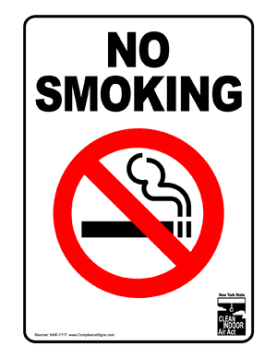
It is the policy of Anna’s Child Care and Early Learning to prohibit the use of tobacco, alcohol, or a potentially toxic substance (other than the substances intended purpose by the manufacturer) in this child care home, when children are present or during the hours of 6:30 am to 5:30 pm, Monday – Friday.
Parents, staff and family members will dispose of tobacco products in an appropriate receptacle prior to entering the home. Any person not complying with this policy will be asked to exit the home and dispose of the product properly.
All child care staff, volunteers and family members present in the home will refrain from using or possessing illegal substances while providing care to children and during hours of operation. Any person suspected of non-compliance with this policy will result in our contacting the appropriate authorities
In an effort to maintain a safe, healthy environment for children, this program has the policy that any person who appears to be intoxicated or otherwise impaired while picking up children for which they are responsible, will be asked to call someone else who is capable of providing safe transport for the child(ren).
Non-compliance with this policy will result in our contacting the appropriate authorities for assistance. Thank you for your cooperation.
This Policy statement will be distributed to each staff member, volunteer and family of a child in care. It is should also be posted in the home.

